India tour 14-30 November 2018
Agra Day 14

Tuesday 27th November 2018
Day 14:- Agra, located slightly north east of Jaipur by 241klms.
Alan awake at 5.00am to repack travel case in readiness for today’s departure from Jaipur to Agra. Travel cases outside room door by 7.45am for a 8.15am departure. Breakfast the usual cereals, mandarin juice, green tea, fruit yoghurt, toast and vegemite. The drive to Agra has a comfort stop after two & a half hours and a second stop for lunch at a wayside eatery similar to the others encountered during the tour. Alan’s standard lunch, cream of mushroom soup with cheese naan bread. Some fridge magnets purchased at the “gift” shop attached to the lunch venue. Cost $au3.00.
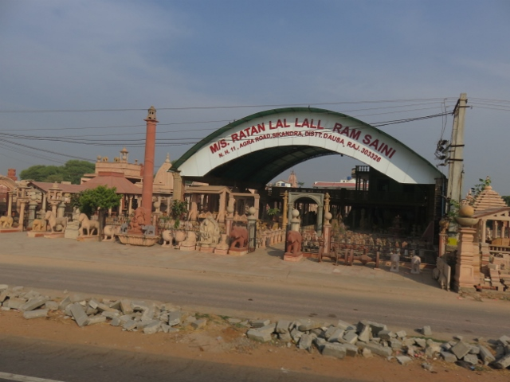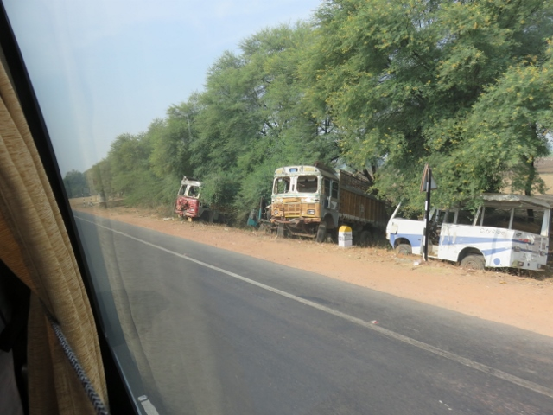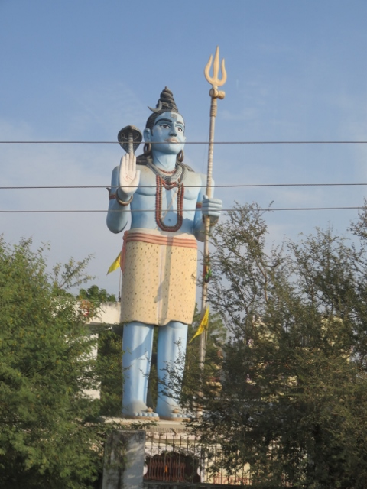
Pottery works and shop on way road safety reminder wrecks off road statue of Hindu god Shiva at roadside.

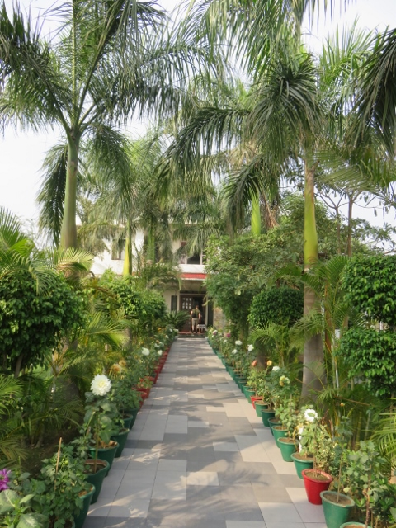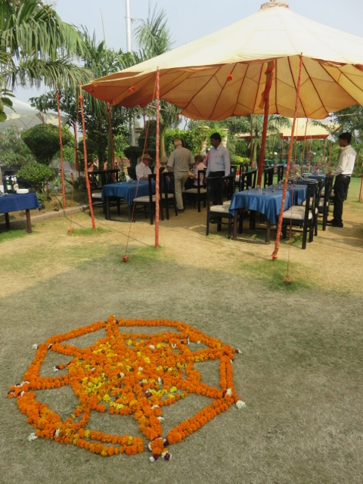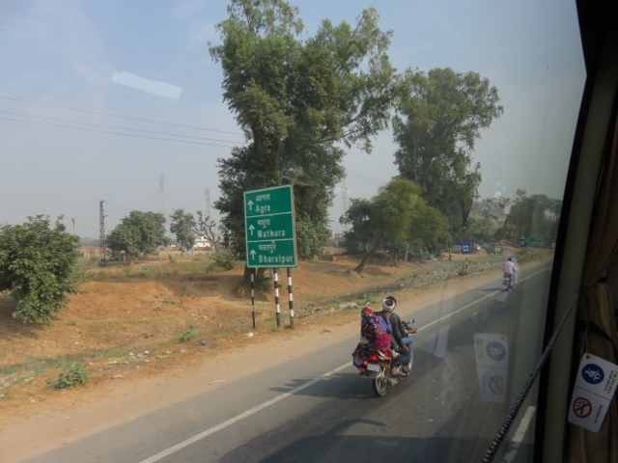
Entrance to pit stop for lunch welcome flower arrangement for lunch motor cyclist + pillion riders.

Next stop after lunch Fatehpur Sikri, an abandoned city built by Emperor Akbar around 1575. It was his capital for some time before returning to Agra. The city is constructed in red sandstone and has similar fort like features. Exiting the bus the group were inundated with flies (read hawkers) on the way to an environmental friendly bus which then took them to the main entrance to the fort and palace. The same procedure for the return to the tour bus was followed upon exiting the site.
There are many buildings of interest within the city walls. Some with ornate carvings at the entrances and within. A large water tank enclosure the size of a football field, was used to store water for the city and now used by locals as a swimming and diving pool. Harch, the Indian tour guide, paid some rupees for one of the daredevils to jump from the wall to the water several metres below. Apparently that is how they earn some money.
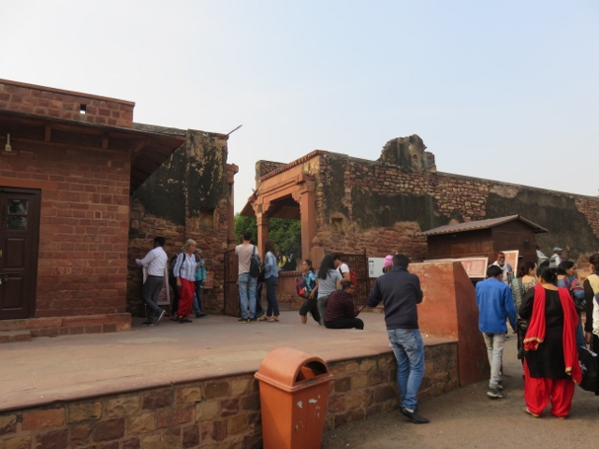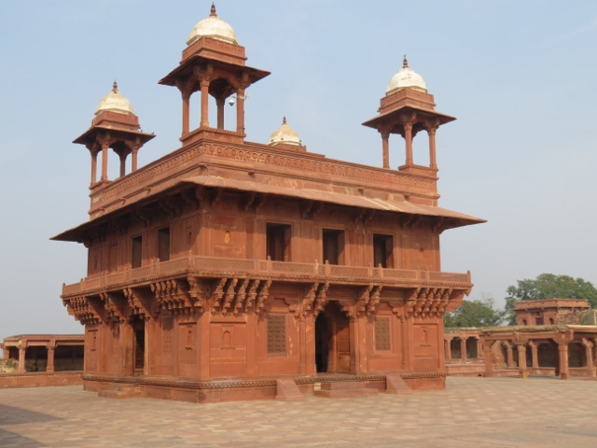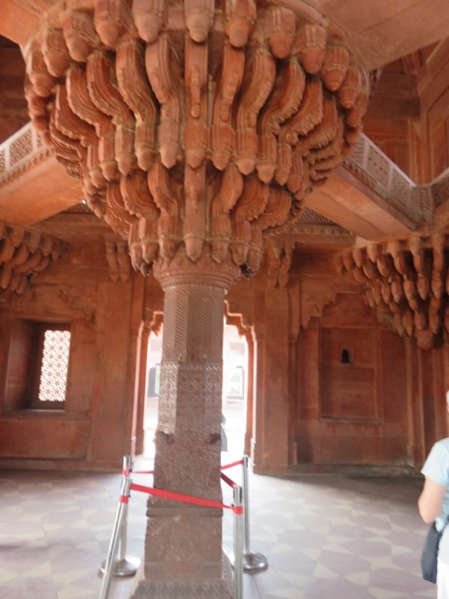
Line up at entrance to Akbar’s city spectacular buildings within decorated central column

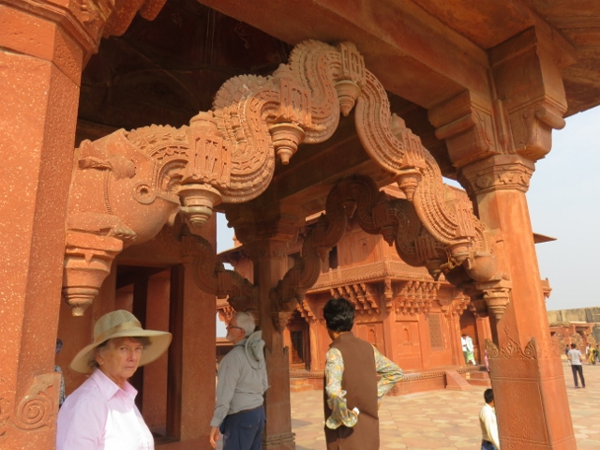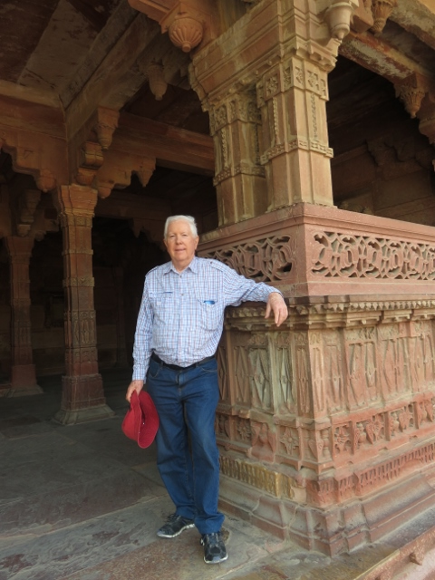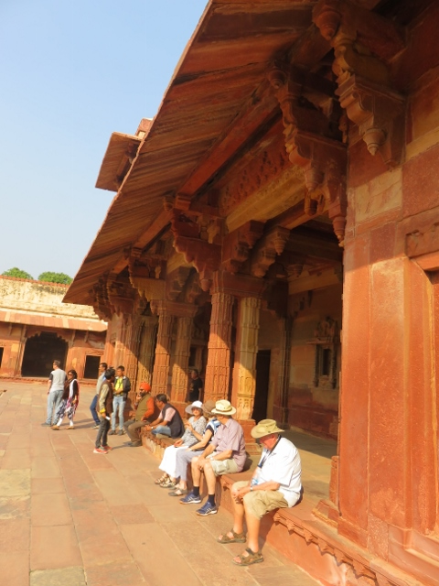
Red sandstone decorated arches Alan at decorated entrance to building Group resting after a long day.

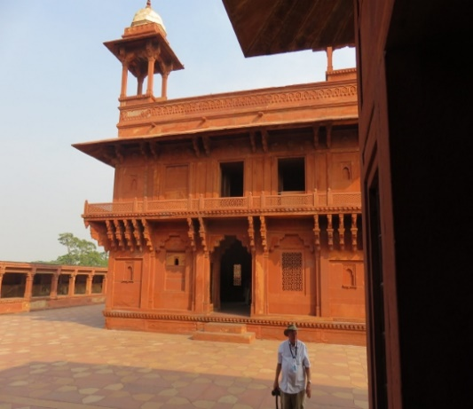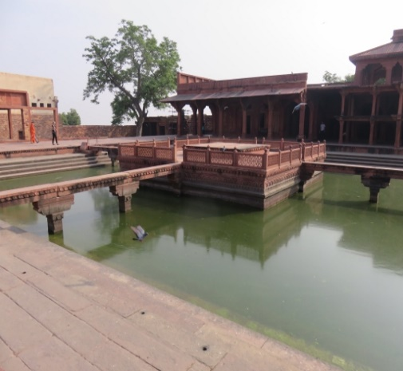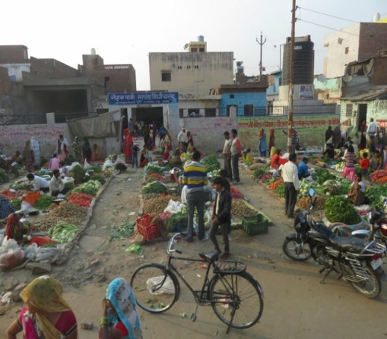
Father Max inspecting building one of the water tanks in city spice sellers on way to Agra.

Back on the bus to Agra, there were several flocks of sheep herded along the side of the road which caused much beeping of vehicle horns in passing. The Trident Hotel was reached at 5.20pm with the necessary collection of passports for reception to allocate room numbers. Alan got room 139. This passport procedure upon arrival at a hotel is standard throughout the tour.
Dinner at 7.00pm was the usual buffet style with plenty of dishes to choose from. The usual precautions to be taken for those of us who would prefer to not have any chilli flavours in the meal. Into bed by 9.00pm.

